Comparative Study of External Parts: Vertebrates

This is an optional activity once the child has explored all five classes of vertebrates with the four-part cards.

It’s presented as a structured conversation.

MATERIALS:
Four-part cards for all five classes of vertebrates (fish, amphibian, reptile, bird, mammal)
Header cards (DIY based on the details of your cards)
- Head
- Chest
- Arms
- Body
- Legs
- Tail

PRESENTATION: Comparative study
Lay out the header cards across the top of a rug or large table.
Lay out the vertebrate class title cards in a column in evolutionary order (First fish, then amphibian, then lizard, then bird and finally mammal).

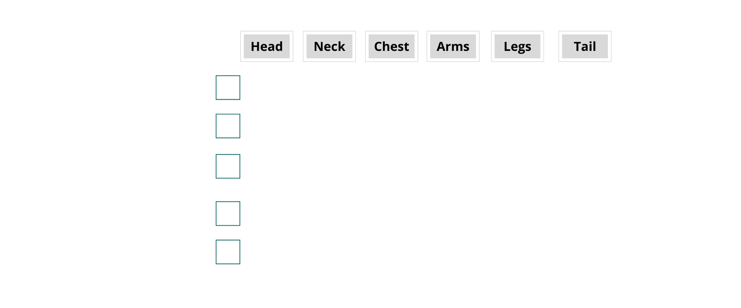
Discuss the characteristics of the head of the fish and place the fish’s “head” image in the empty space under “head” and to the right of “fish.”
Then bring out the “head” card for the amphibian and discuss any similarities and differences between the fish head and the amphibian head. Place the amphibian head card below the fish head card.
Continue one by one with each “head” card, discussing and placing in the right spot.
Move on to the “chest” card for the fish (which might be the pectoral fins, depending on your card set).
Continue working down the “chest” column, discussing similarities and differences.
Start on the third column, focusing on “arms” (or in the case of the fish, fins and in the case of the bird, wings).
Continue the conversation for each external body part.
Invite the child to admire the work and invite any concluding thoughts.

Possible extension: Take out the Timeline of Life to explore the evolution of one or more classes of animals.

